1. 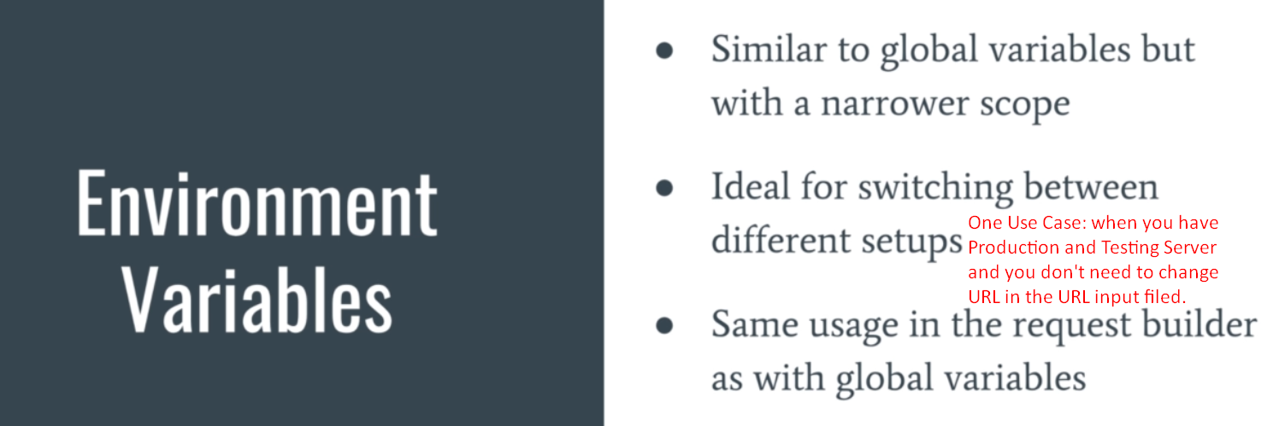
2. 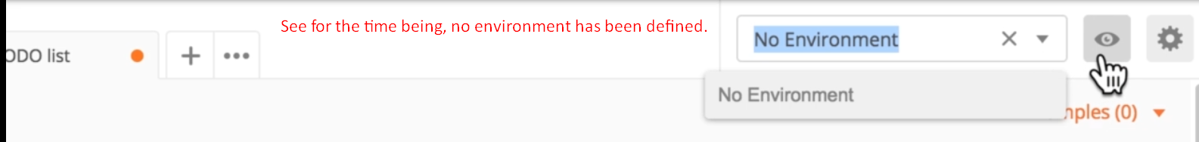
3. 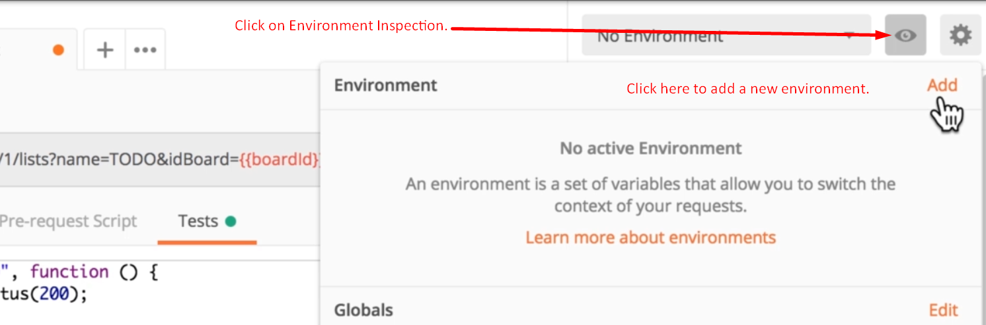
4. You may need two different environments in the following cases
   1. Maybe you have two different accounts (username and password)
   2. Maybe you have two different URLs (Production, Testing, Local Servers)
5. **NOTE**: you can use same request for different environments.
6. 